# Q1

* In slow start, a sender doubles its window size every RTT

if all sent packets were acknowledged

*  True

# Q2

* In steady state, a sender increases its window size by one

packet for each acknowledgement

*  False

# Q3

 A sender that underestimates the round-trip time of a

connection may unnecessarily induce a TCP timeout  True

# Q4

* After detecting packet loss through a timeout, TCP halves

its window size as a response to the path congestion

*  False

# Q5

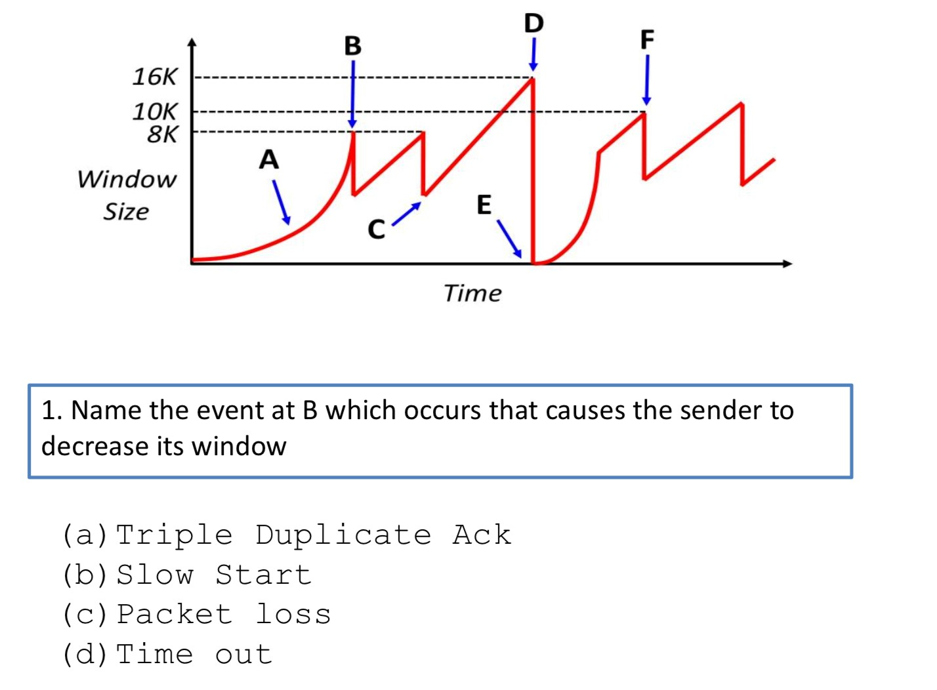

1. Triple Duplicate Ack

# Q6

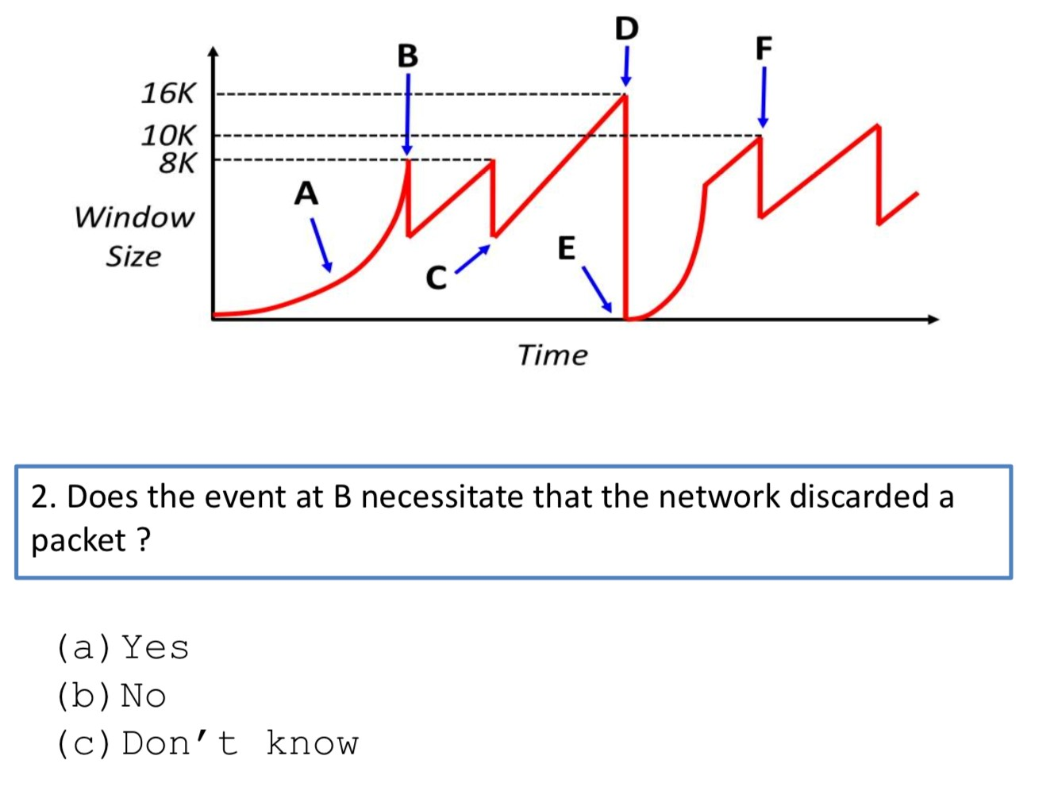

1. No

# Q7

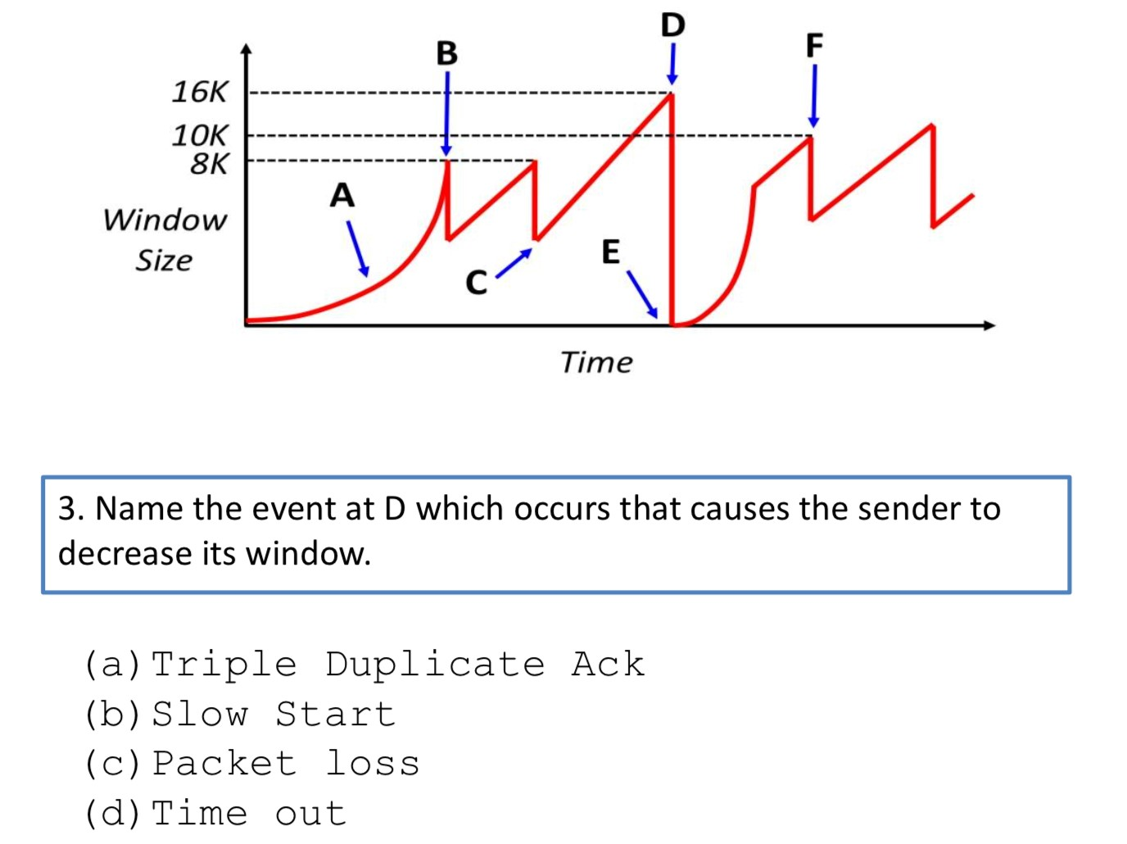

1. Time Out

# Q8

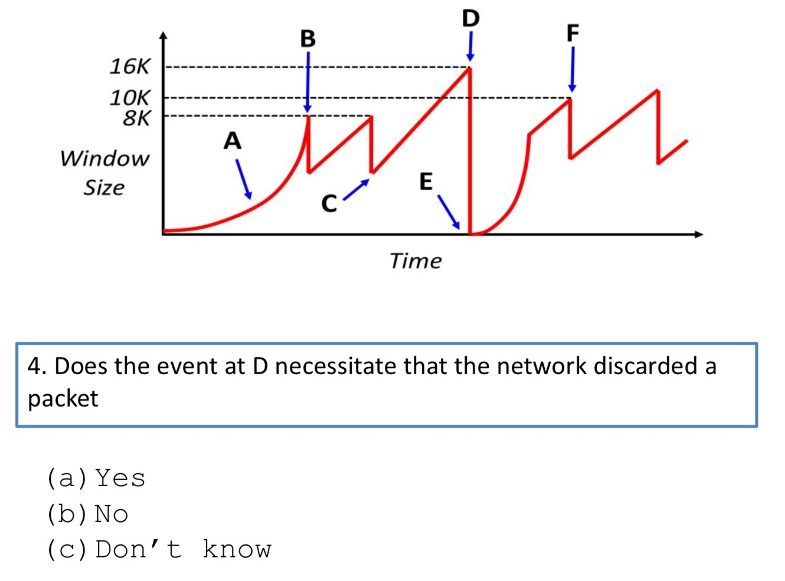

1. No

# Q9

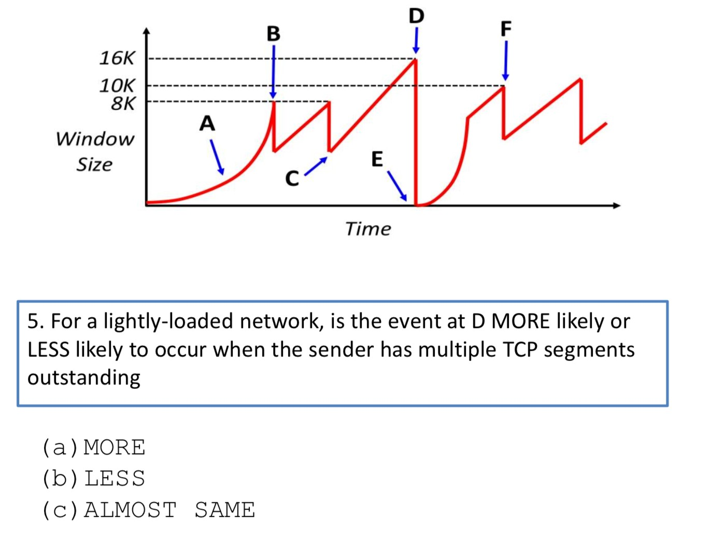

(c) Less

# Q10

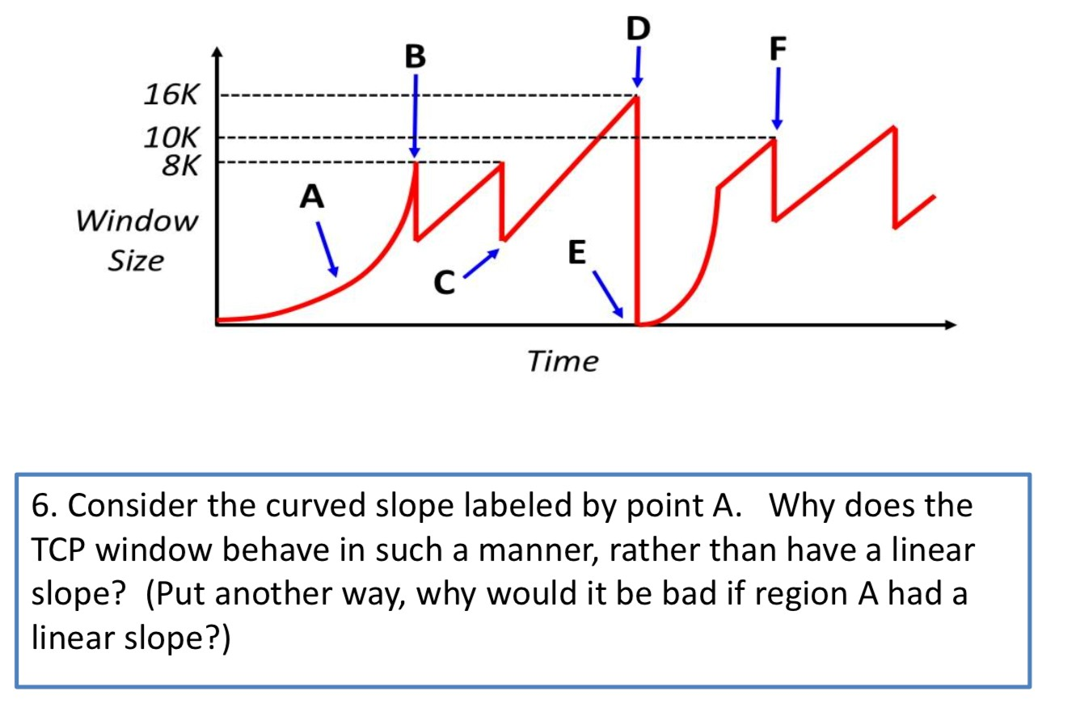

Ans: Point A is a Slow Start.

# Q11

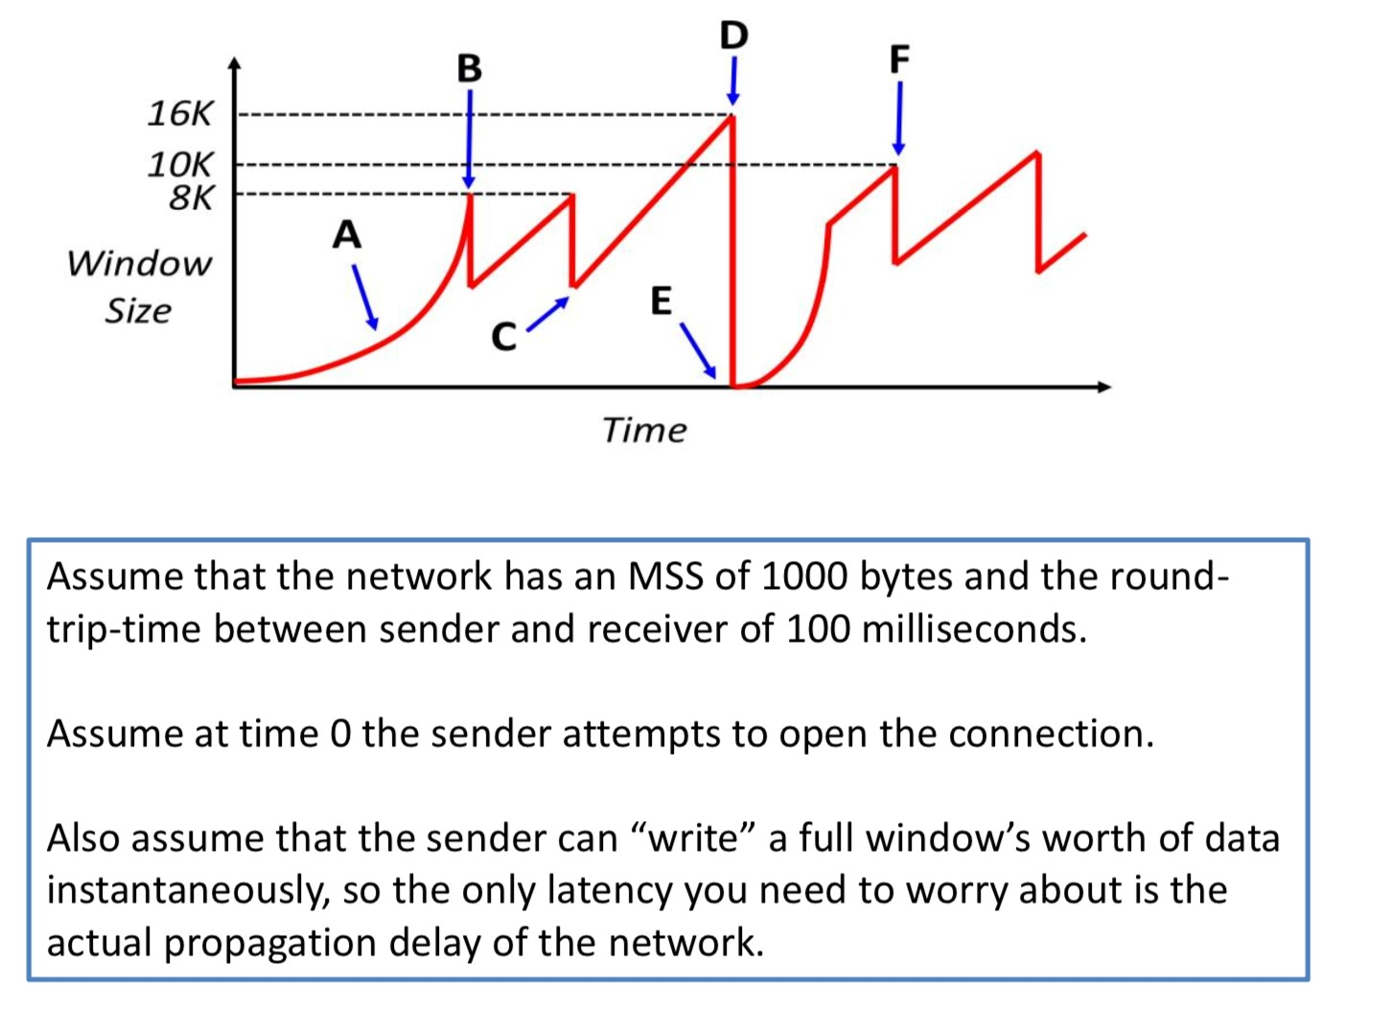

# Q12

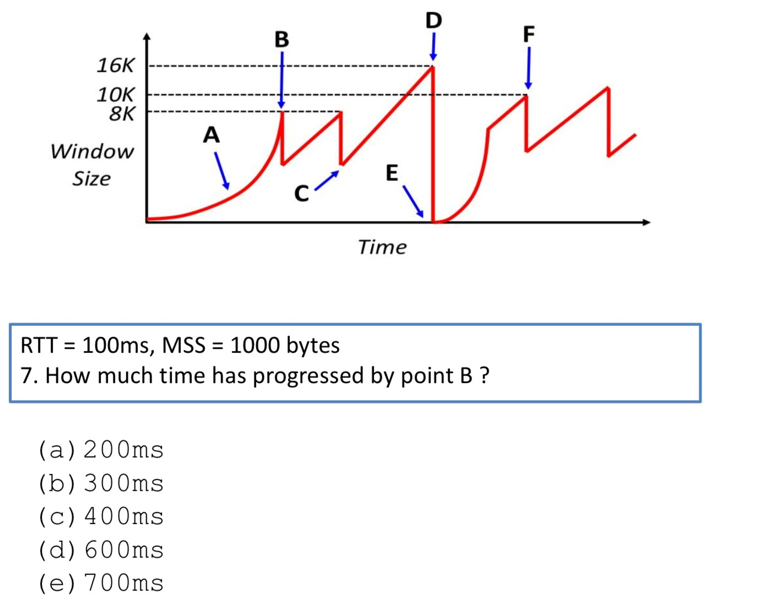

1. 400ms

# Q13

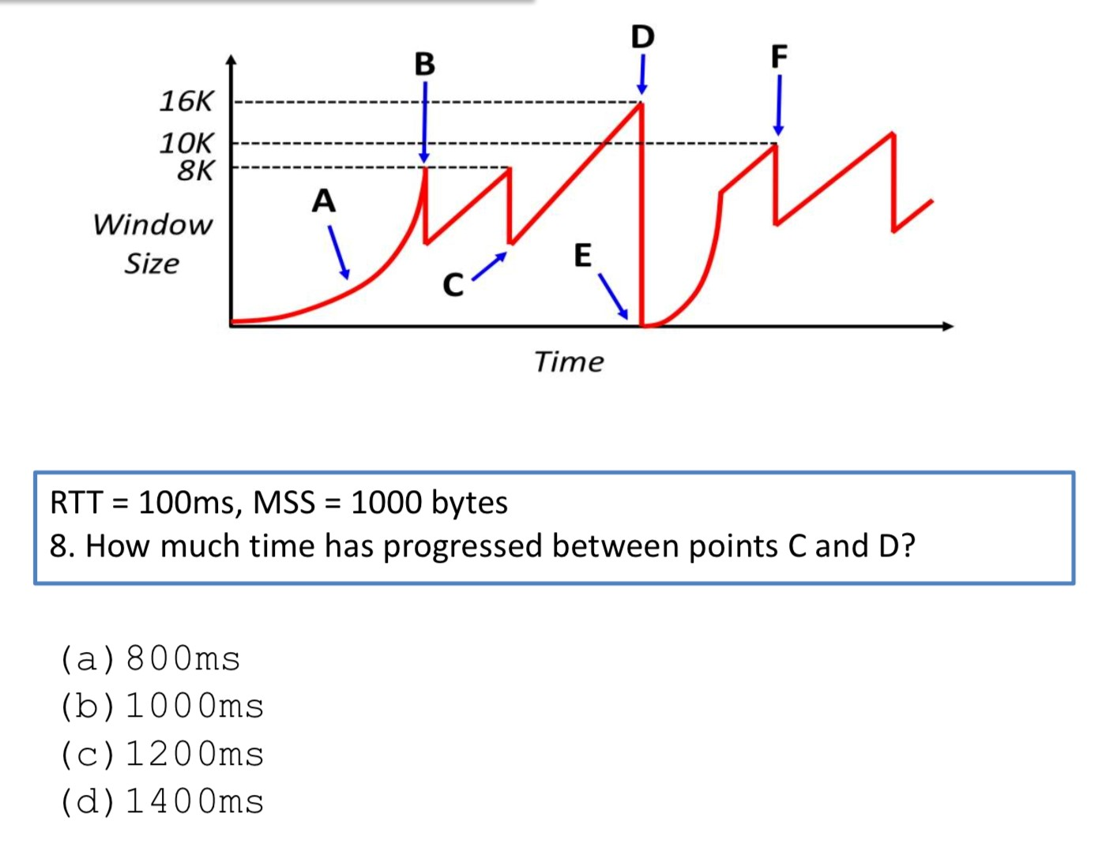

(c)1200ms

# Q14

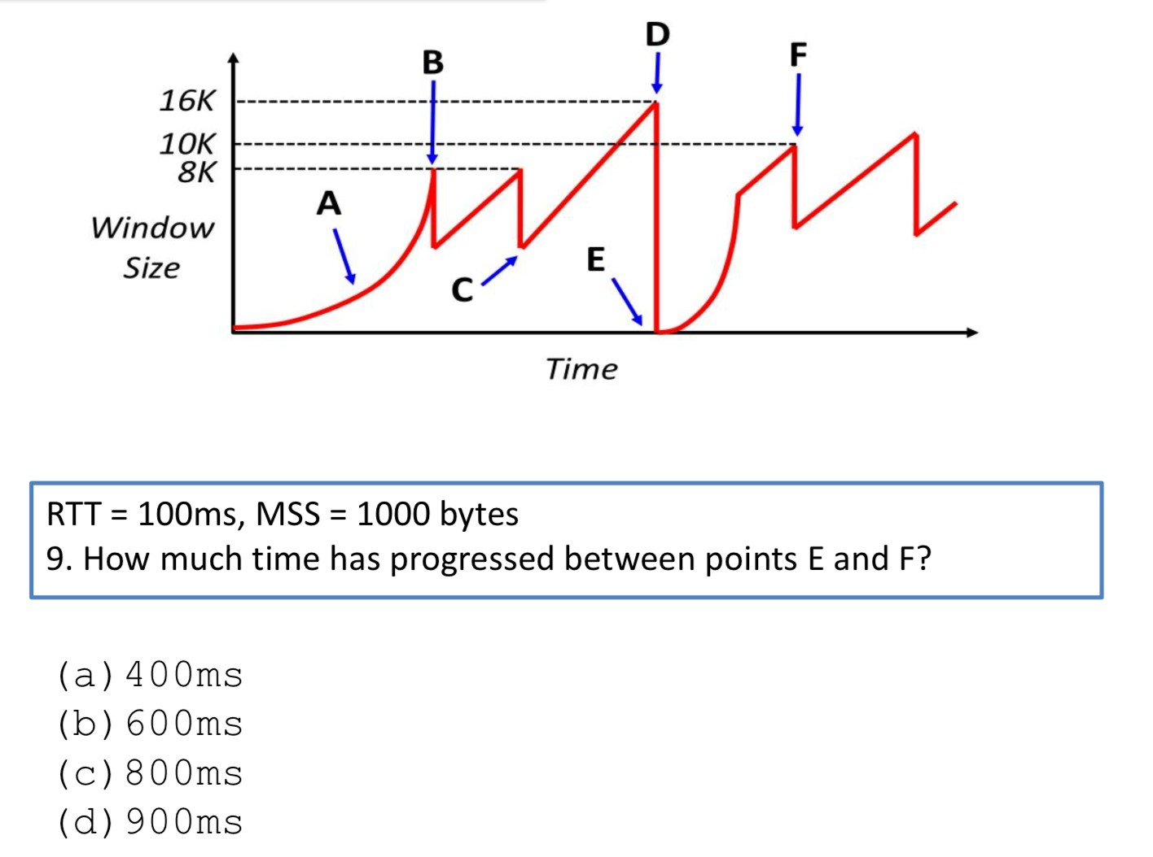

1. 600ms

# Q15

